B - Circle in a Rectangle

Write a program which reads a rectangle and a circle, and determines whether the circle is arranged inside the rectangle. As shown in the following figures, the upper right coordinate (W, H) of the rectangle and the central coordinate (x, y) and radius r*r* of the circle are given.

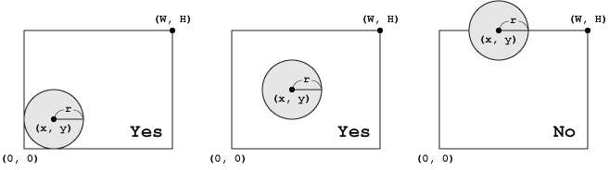

**Input**

Five integers W,*H*, x, y and rseparated by a single space are given in a line.

**Output**

Print "Yes" if the circle is placed inside the rectangle, otherwise "No" in a line.

**Constraints**

* -100 <= x, y <=100
* 0 < W, H, r <= 100

**Sample Input 1**

5 4 2 2 1

**Sample Output 1**

Yes

**Sample Input 2**

5 4 2 4 1

**Sample Output 2**

No

#include <iostream>

using namespace *std*;

int main(void)

{

int w, h, x, y, r;

*cin* >> w >> h >> x >> y >> r;

if( ((x - r) >= 0) && ((y - r) >= 0) && ((x + r) <= w) && ((y + r) <= h))

*cout* << "Yes" << *endl*;

else

*cout* << "No" << *endl*;

return 0;

}